**National College of Ireland**

**Project Submission Sheet**

|  |  |  |  |
| --- | --- | --- | --- |
| **Student Name:** | Olamide Abioro, Muhammad Osama Hassan Khan, Liton Nath  ……………………………………………………………………………………………………………… | | |
| **Student ID:** | x23428902, x24137782, x23402661  ……………………………………………………………………………………………………………… | | |
| **Programme:** | MSCDAD_C  ……………………………………………………………… | **Year:** | 2025  ……………………… |
| **Module:** | Business Intelligence & Business Analytics  ……………………………………………………………………………………………………………… | | |
| **Lecturer:** | Pritesh Tiwari  ……………………………………………………………………………………………………………… | | |
| **Submission Due Date:** | August 3, 2025  ……………………………………………………………………………………………………………… | | |
| **Project Title:** | Business Intelligence & Analytics Transformation  Eason Sons & Ltd  ……………………………………………………………………………………………………………… | | |
| **Word Count:** | 1,805  ……………………………………………………………………………………………………………… | | |

I hereby certify that the information contained in this (my submission) is information pertaining to research I conducted for this project. All information other than my own contribution will be fully referenced and listed in the relevant bibliography section at the rear of the project.

ALL internet material must be referenced in the references section. Students are encouraged to use the Harvard Referencing Standard supplied by the Library. To use other author's written or electronic work is illegal (plagiarism) and may result in disciplinary action. Students may be required to undergo a viva (oral examination) if there is suspicion about the validity of their submitted work.

|  |  |
| --- | --- |
| **Signature:** | Olamide Abioro, Muhammad Osama Hassan Khan, Liton Nath  ……………………………………………………………………………………………………………… |
| **Date:** | August 1, 2025  ……………………………………………………………………………………………………………… |

**PLEASE READ THE FOLLOWING INSTRUCTIONS:**

1. Please attach a completed copy of this sheet to each project (including multiple copies).

2. Projects should be submitted to your Programme Coordinator.

3. **You must ensure that you retain a HARD COPY of ALL projects**, both for your own reference and in case a project is lost or mislaid. It is not sufficient to keep a copy on computer. Please do not bind projects or place in covers unless specifically requested.

4. You must ensure that all projects are submitted to your Programme Coordinator on or before the required submission date. **Late submissions will incur penalties.**

5. All projects must be submitted and passed in order to successfully complete the year. **Any project/assignment not submitted will be marked as a fail.**

|  |  |
| --- | --- |
| **Office Use Only** | |
| Signature: |  |
| Date: |  |
| Penalty Applied (if applicable): |  |

Business Intelligence & Analytics Transformation Eason Sons & Ltd

Project Specification Report

Olamide Abioro : [x23428902@student.ncirl.ie](mailto:x23428902@student.ncirl.ie) Muhammad Osama Hassan Khan : [x24137782@student.ncirl.ie](mailto:x24137782@student.ncirl.ie)

Liton Nath : [x23402661@student.ncirl.ie](mailto:x23402661@student.ncirl.ie)

# Abstract

Eason Sons & Ltd is an established Irish retail business experiencing critical operational and financial challenges. This report details a comprehensive business intelligence (BI) and ana- lytics transformation strategy, leveraging Power BI for dashboard infrastructure and Salesforce for customer relationship management (CRM). Key analyses, system architecture, database design, data preparation, and academic justification are presented, with recommendations for revitalizing business performance.

# Background Information and Business Goals

## Organisational Background

Eason & Son Ltd. is a long-established book and stationery chain that has been part of Ireland’s retail landscape since 1886. Over the years, it has grown to become the largest and most recog- nized retailer of its kind in Ireland. For almost a century, Eason has established strong links with Irish consumers, particularly through landmark locations like the flagship on O’Connell Street in Dublin. The company’s success has traditionally stemmed from its main product offerings, a dedicated customer base, robust sales of schoolbooks, and an extensive retail presence throughout the Republic of Ireland and Northern Ireland.

However, the retail industry has shifted considerably in the last decade. Eason now faces fierce competition from global giants such as Amazon and Tesco, alongside local independent

bookstores with dedicated followings. Digital formats such as eBooks, audiobooks, and fast de- livery services have impacted old retail structures. These technological shifts have put pressure on both Eason’s physical stores and its online presence.

Foot traffic in city centers has decreased, caused by the COVID-19 pandemic. This has forced Eason to close several stores over recent years, with further downsizing a concern. Eason still has vital assets, such as a strong brand, a solid but diminishing customer base, and a presence in important markets, even though things are tough.

## Market Overview

Eason & Son Ltd. has significant operational and strategic problems in today's competitive retail environment. Strong competition from internet behemoths and shifting customer habits have exposed flaws in Eason's antiquated e-commerce platform, which struggles to fulfill modern demands for customized service and seamless, multi-channel shopping.

Data varies across historical systems, obsolete tills, spreadsheets, and unreliable loyalty databases, making it difficult to gain clear insights and manage inventory effectively. Physical store sales have fallen by almost 30% in the last three years, while internet growth has lagged. Customer engagement suffers due to inactive loyalty accounts and poor contact data. Inventory management is inconsistent, and strained supplier relationships add further pressure. Fixed costs are high despite decreased revenue, reducing profitability. Together, these concerns underline the critical need for digital and cultural transformations.

## Strategic Business Goals

To address these existential threats, Eason has articulated the following objectives:

### Achieve Profitability Within Two Years

The primary goal of Eason & Son Ltd is to end financial losses and return to profitability within 24 months. This includes reassessing costs, improving store performance, closing underperforming branches, and reducing unnecessary overheads. Leveraging business intelligence tools should allow for more informed and faster financial decisions.

### Grow Online and Multi-Channel Sales

Eason aims for at least 30% of its sales to come from online and multi-channel (omni-channel) platforms. To attract more tech-savvy customers, plans include streamlining the online experience and connecting it with in-store services such as click-and-collect and loyalty programs.

### Modernize the Customer Experience

Enhancing customer experience is essential. By implementing a new CRM, Eason will personalize offers, improve loyalty programs, and strengthen communication. The focus is on recognizing individual customer needs, quick responses, and making each visit more rewarding.

### Fix Stock and Supply Chain Problems

Improving inventory management is crucial. Eason plans to use new forecasting and stock analysis techniques to reduce overstock and out-of-stock situations, improve supplier cooperation, and keep shelves stocked with the right products. This should reduce waste and improve customer satisfaction.

### Rebuild Stakeholder Trust

Rebuilding trust with suppliers, employees, and customers is critical. Years of poor performance have harmed relationships; therefore, Eason is devoted to transparent communication, timely payments, professional dealings, and keeping promises. For staff, this also means more training and openness to change.

Despite initial resistance to change, Eason & Son Ltd recognises the value of transformation for survival. With a renewed emphasis on business intelligence and CRM, the company intends to modernize, strengthen its position, and create a sustainable, customer-focused future.

## Exploratory Data Analysis (EDA)

The analysis of transactional, customer, and inventory data reveals:

* **Sales Decline:** Since 2020, sales have declined by 27% annually, with only the Dublin flagship shop showing progress.
* **Loyalty:** Repeat purchase rates are below 15% (industry norm: 25–30% [1]); loyalty signups fell 40% since 2022.
* **Inventory Turnover:** The ratio is 2.1 (optimal is 4–6 [2]); nearly half of SKUs contribute less than 2% of sales.
* **Customer Feedback:** Surveys show dissatisfaction with stock availability, a lack of personalization, and inconsistent service.

## Gap Analysis and SWOT Assessment

**Strengths:** Brand awareness, store network, staff experience.

**Weaknesses:** Outdated IT systems, inefficient data usage, and slow adaptation. **Opportunities:** BI and CRM implementation, multichannel retail, educational partnerships. **Threats:** Online competition, evolving preferences, rising costs.

# System Design

## Solution Overview

A combined BI and CRM solution is proposed:

* **Power BI:** Centralised dashboarding and analytics.
* **Salesforce CRM:** Unified customer relationship management.

## Data Capture Points

* Sales transactions via POS.
* Inventory movements from ERP.
* Customer interactions (web, email, loyalty, in-store).
* Staff activity logs.
* Marketing campaigns and responses.

## Analytical and Reporting Requirements

* Real-time and historical sales dashboards for each store, region, and category.
* Customer segmentation to enable targeted marketing.
* Inventory health and re-order monitoring.
* Campaign effectiveness analysis.
* Predictive analytics (demand & recommendations).

## Customer Integration

Salesforce CRM enables:

* Personalised communications and promotions.
* Automated loyalty tracking to reward and attract customers.
* Coordinated cross-channel customer profiles for smooth experiences.
* Systematic feedback gathering and analysis for continuous development.

## System Architecture

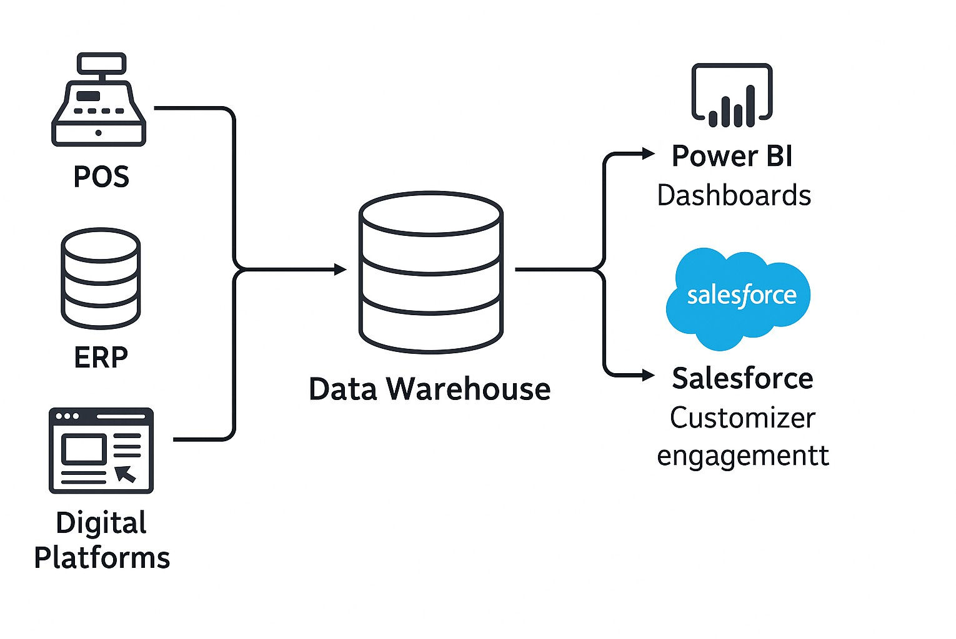

Figure 1: System Architecture.

Data from POS, ERP, and digital platforms is transmitted through an ETL layer to a central data warehouse. Power BI creates dashboards, while Salesforce maintains customer engagement.

# Database Design

## Entity-Relationship Model

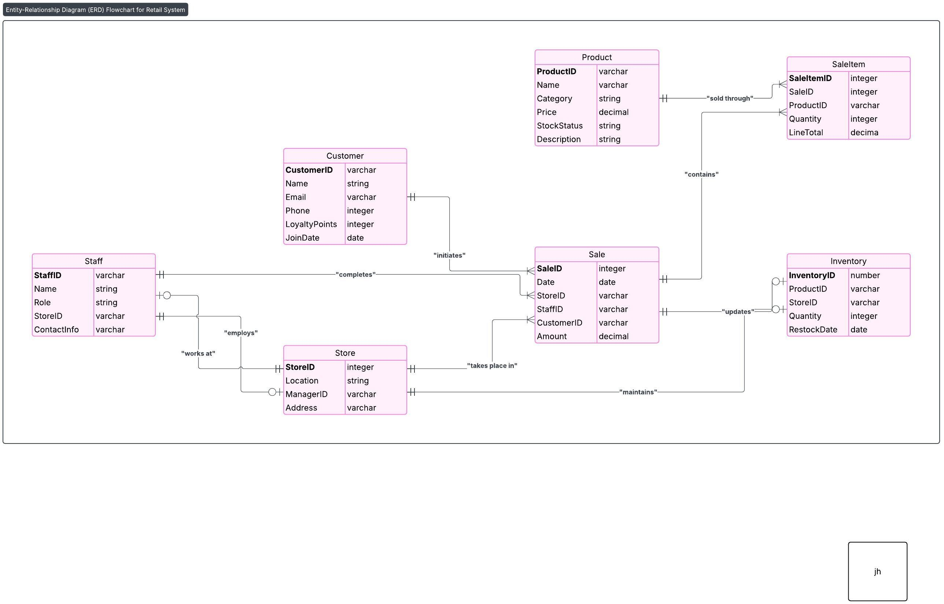

Figure 2: Entity-Relationship Diagram (ERD).

The Entity-Relationship Diagram (ERD) for the Eason Sons & Ltd retail system provides a visual overview of the key data entities and their relationships within the business. Each table in the diagram represents a critical aspect of the business, such as customers, products, sales, inventory, staff, and stores.

The Sale entity is at the heart of the ERD, recording each transaction and connecting customers (who make purchases), staff (who process sales), and stores (where sales occur). The SaleItem entity links each sale to the individual products sold, allowing for detailed tracking of every item within a transaction. The Inventory entity manages stock levels for each product at each store location, resulting in more effective supply chain management.

Staff members are assigned to specific stores, while each store is managed by a staff mem- ber. The diagram also highlights how products, customers, and staff interact within daily busi- ness activities. Primary and foreign keys are utilized throughout to ensure data integrity and proper table connectivity.

This ERD organizes information in a systematic and logical manner, supporting both op- erational demands and business intelligence objectives for Eason Sons & Ltd. It forms the foundation for building reliable analytics, dashboards, and CRM functionalities.

* 1. **Data Dictionary**

|  |  |  |  |
| --- | --- | --- | --- |
| **Entity** | **Field** | **Type** | **Description** |
| Customer | CustomerID | Varchar | Unique customer identifier |
| Name | Varchar | Full name |
| Email | Varchar | Email address |
| Phone | Varchar | Contact number |
| LoyaltyPoints | Integer | Loyalty programme points |
| JoinDate | Date | Loyalty enrolment date |
| Product | ProductID | Varchar | Unique product identifier |
| Name | Varchar | Product name |
| Category | Varchar | Product category |
| Price | Decimal | Retail price |
| StockStatus | Varchar | In stock/out of stock |
| Sale | SaleID | Integer | Unique sale identifier |
| Date | DateTime | Sale date/time |
| StoreID | Integer | Store reference |
| StaffID | Integer | Staff member responsible |
| CustomerID | Integer | Customer reference (nullable) |
| SaleItem | SaleItemID | Integer | Unique line item |
| SaleID | Integer | Related sale |

|  |  |  |  |
| --- | --- | --- | --- |
|  | ProductID | Integer | Product reference |
| Quantity | Integer | Units sold |
| LineTotal | Decimal | Price *×* Quantity |
| Inventory | InventoryID | Integer | Unique inventory record |
| ProductID | Integer | Product reference |
| StoreID | Integer | Store reference |
| Quantity | Integer | Units on hand |
| RestockDate | Date | Last restocked |
| Staff | StaffID | Varchar | Unique staff ID |
| Name | Varchar | Full name |
| Role | Varchar | Position/title |
| StoreID | Integer | Store assignment |
| Store | StoreID | Varchar | Unique store ID |
| Location | Varchar | Address |
| ManagerID | Integer | StaffID of manager |

# Mock Data and Data Structures

## Mock Data Generation

Mock data was generated using Mockaroo to simulate realistic operations:

* 10,000 customer records (demographics, loyalty).
* 3,000 product SKUs.
* 100,000 sales transactions.
* Store-level inventory records.
* 500 staff entries.

## Sample Data Customer Entity

|  |  |  |  |  |
| --- | --- | --- | --- | --- |
| CustomerID | Name | Email | LoyaltyPoints | JoinDate |
| 10001 | John Kelly | [johnk@email.com](mailto:johnk@email.com) | 220 | 2022-03-19 |
| 10002 | Maeve O’Connor | [maeve.oc@email.com](mailto:maeve.oc@email.com) | 145 | 2023-01-04 |
| ... | ... | ... | ... | ... |

Table 2: Sample Customer Records

## Product Entity

|  |  |  |  |  |  |
| --- | --- | --- | --- | --- | --- |
| ProductID | Name | Category | Price | StockStatus | Description |
| 2001 | The Great Gatsby | Book | 9.99 | In Stock | Novel by F. Scott Fitzgerald |
| 2002 | Staedtler Pen Set | Stationery | 5.49 | In Stock | Pack of 4 assorted pens |
| ... | ... | ... | ... | ... | ... |

Table 3: Sample Product Records

## Sale Entity

|  |  |  |  |  |  |
| --- | --- | --- | --- | --- | --- |
| SaleID | Date | StoreID | StaffID | CustomerID | Amount |
| 30001 | 2024-01-12 | 10 | 4002 | 10002 | 27.48 |
| 30002 | 2024-01-13 | 10 | 4003 | 10001 | 9.99 |
| ... | ... | ... | ... | ... | ... |

Table 4: Sample Sale Records

## SaleItem Entity

|  |  |  |  |  |
| --- | --- | --- | --- | --- |
| SaleItemID | SaleID | ProductID | Quantity | LineTotal |
| 50001 | 30001 | 2002 | 2 | 10.98 |
| 50002 | 30001 | 2005 | 1 | 20.00 |
| ... | ... | ... | ... | ... |

Table 5: Sample SaleItem Records

## Inventory Entity

|  |  |  |  |  |
| --- | --- | --- | --- | --- |
| InventoryID | ProductID | StoreID | Quantity | RestockDate |
| 60001 | 2001 | 10 | 30 | 2023-12-20 |
| 60002 | 2002 | 10 | 50 | 2023-12-22 |
| ... | ... | ... | ... | ... |

Table 6: Sample Inventory Records

## Staff Entity

|  |  |  |  |  |
| --- | --- | --- | --- | --- |
| StaffID | Name | Role | StoreID | ContactInfo |
| 4001 | Mary O’Brien | Store Manager | 10 | [mary.obrien@eason.ie](mailto:mary.obrien@eason.ie) |
| 4002 | Tom Murphy | Sales Lead | 10 | [tom.murphy@eason.ie](mailto:tom.murphy@eason.ie) |
| ... | ... | ... | ... | ... |

Table 7: Sample Staff Records

## Store Entity

|  |  |  |  |
| --- | --- | --- | --- |
| StoreID | Location | ManagerID | Address |
| 10 | O’Connell St, Dublin | 4001 | 40 O’Connell St, Dublin 1 |
| 11 | Cork City Centre | 4006 | 2 Patrick St, Cork |
| ... | ... | ... | ... |

Table 8: Sample Store Records

## Data Pre-Processing

* + 1. Data cleaning: Removal of duplicates and format standardization.
    2. Handling missing values: Imputation for manual review.
    3. Integration: Merging datasets via unique IDs.
    4. Transformation: Creation of derived variables, ISO 8601 date conversion.
    5. Validation: Logical checks (e.g., inventory totals, sale item sums).

# Discussion and Justification

## Justification for Power BI

Power BI was chosen for its flexibility, interactive features, and simplicity of integration with diverse data sources. It enables rapid visualisation and dissemination of business insights [3].

## Justification for Salesforce CRM

Salesforce CRM is widely recognised for robust customer lifecycle management, segmentation, and automation. Its scalability and integration ecosystem align with Eason’s requirements [4].

# References

1. KPMG, “Retail Customer Retention Benchmarks,” KPMG Insights, 2022.
2. Deloitte, “Inventory Management Best Practices in Retail,” Deloitte Insights, 2023.
3. Microsoft, “Power BI: Features and Benefits,” Microsoft Whitepaper, 2024.
4. Salesforce, “Customer Success Stories,” Salesforce.com, 2023.

Business Intelligence & Analytics Transformation Eason Sons & Ltd

Project Implementation Report

Olamide Abioro : [x23428902@student.ncirl.ie](mailto:x23428902@student.ncirl.ie) Muhammad Osama Hassan Khan : [x24137782@student.ncirl.ie](mailto:x24137782@student.ncirl.ie)

Liton Nath: [x23402661@student.ncirl.ie](mailto:x23402661@student.ncirl.ie) August 1, 2025

# Introduction

Eason Sons & Ltd, a retail company operating in Ireland, recently experienced serious opera- tional inefficiencies, data fragmentation, and declining sales. To address these issues, a business intelligence and customer relationship management solution was developed using Salesforce for CRM and Power BI for reporting.

This report focuses on the implementation phase of the Salesforce CRM system and Power BI. It outlines the development steps, system configuration, access controls, and data validation strategies used to improve business operations. It also assesses the degree to which the new system has addressed the business’s original pain points and provides early observations on performance improvements and potential areas for future enhancement.

# Development Process

## From Conceptualisation to Implementation

The BI and CRM technologies were implemented using a structured, phased approach. Initially, the project began with the conceptual design phase, which referenced previously defined specifications. This stage involved defining essential business needs, system architecture, database design, and selecting suitable platforms, such as Salesforce for CRM and Power BI for analytics.

During the implementation phase, mock datasets were created with Mockaroo and then uploaded into PostgreSQL. Salesforce CRM was configured after extensive data validation and cleansing, with custom objects, fields, relationships, validation rules, and user profiles created to meet the organization's specific requirements. At the same time, dashboards and reports were created in Power BI, using PostgreSQL as the primary data source.

## Additional Validation Rules

Several unexpected elements emerged during implementation, requiring adjustments to the ini- tial plan:

### Salesforce Data Upload Limitations

Salesforce restricts bulk uploads to a maximum of 50,000 records per import operation [1]. This constraint was not initially anticipated, and as a result, larger datasets, particularly Sales and SaleItems, were reduced or divided into smaller segments. This necessitated additional data processing steps and careful checks to maintain data integrity and accuracy.

### Handling Relationships in Power BI

Power BI allows just one relationship between two tables to be active at any given time. When several relationships exist, the inactive ones can still be used for computations by manually activating them within specific measures using the USERELATIONSHIP() function in DAX. This approach allows for flexible analysis based on alternative relationships without altering the overall data model structure.

### Adjustment of Data Types and Field Formats

During the data import and mapping phase, we noticed that some fields, like phone numbers and dates, needed to be reformatted to meet Salesforce’s strict field type requirements. Dates, for instance, had to be in the YYYY-MM-DD format, and we had to standardize phone numbers to ensure everything uploaded smoothly.

# System Implementation

## Salesforce CRM Configuration

### Objects, Fields, and Relationships

Salesforce was configured to meet Eason Sons & Ltd’s specific operational needs by setting up custom objects, fields, and relationships. Key custom objects created include Customers, Sales, Products, Staff, Stores, Inventory, and Sale Items.

The Customer object was created to manage detailed customer information, including fields like Name, Email, Phone, LoyaltyPoints, and Marketing Consent.

The Sales object tracks transactional data, including Date, Store, Customer, Staff, and SaleIt-

ems . Relationships between objects were defined via Lookup fields, clearly shown in the provided screenshot.

Figure 1: Salesforce Custom Object Setup / Fields & Relationship

### Validation Rules and Page Layouts

Figure 2: Customer Validation Rule

Validation rules were set to maintain data integrity. For instance, a validation rule for the Customer object was established to ensure that loyalty points cannot be negative.

Page layouts were configured to enhance user interaction and ensure essential fields were ac- cessible and logically grouped, demonstrated clearly through screenshots provided in the setup process.

## Access Controls and Sharing Rules

### Profiles and Permissions

Figure 3: Store Manager vs Sales Staff Profile Permissions screenshot

Profiles were carefully configured to ensure users had appropriate access. Two critical profiles including, Store Manager and Sales Staff were set up, with distinct permissions.

* + - * Store Manager Profile: Provided full access to read, create, and edit most records within their store, including sensitive fields like Sales Amount (Figure 5 & 6: Store Manager

Profile Permissions screenshot).

* + - * Sales Staff Profile: Restricted permissions, primarily read-only access, and limited visi- bility to sensitive data, as demonstrated in subsequent testing.

### Field-Level Security and Sharing

Figure 4: Sharing Settings for Sales Records screenshot

Field-level security was implemented to restrict sensitive fields. For example, the LineTotal (Sales Amount) was configured to be visible only to authorized profiles, ensuring data privacy.

Sharing rules were defined to ensure store-specific data visibility. A specific rule was set to allow staff within the same store to view relevant sales records, enhancing operational effi- ciency while maintaining data confidentiality (Figure 8: Sharing Settings for Sales Records screenshot).

### Testing Access Controls

To validate these configurations, comprehensive testing was performed using the Salesforce “Login As” feature:

The Sales Staff profile was tested to ensure restricted access, demonstrated by the” Insufficient Privileges” message encountered when attempting to access detailed staff information.

The Store Manager profile demonstrated full access and visibility to the same staff information, highlighting the correct implementation of permissions.

This thorough testing confirmed that access controls and permission settings functioned as intended, clearly distinguishing data visibility based on user roles and ensuring compliance with organizational data policies.

Figure 5: Salesforce Custom Object Setup

# Reports and Dashboards

## Power BI Integration

Following the deployment of Salesforce CRM, the next phase focused on data analytics and interactive reporting using Microsoft Power BI. Data from PostgreSQL, populated with the

cleansed and integrated business data, was connected directly to Power BI. The architecture and process for this implementation are described in detail below.

## Relationship Modeling & DAX

Relationships were established to mirror the logical connections between the seven tables stored in PostgreSQL. These relationships are fundamental for accurate reporting, ensuring that mea- sures and dimensions are appropriately joined during aggregation and filtering.

Figure 6: Power BI Sales Dashboard

Relationships were created manually in the “Manage Relationships” view. Measures and calcu- lated columns were defined using DAX for custom KPIs such as total sales, Inventory Turnover rate, Instock% , out of stock%, low stock%, top 5 performing product, top 5 underperforming products, customer segment,purchase count, customer type, last 6 month active customer.

**KPI**:

customer_Segment = SWITCH(

TRUE(),

SELECTEDVALUE(’public cust’[loyaltypoints]) < 100, "Bronze", SELECTEDVALUE(’public cust’[loyaltypoints]) >= 100 && SELECTEDVALUE SELECTEDVALUE(’public cust’[loyaltypoints]) > 300, "Platinum"

)

Figure 7: DAX formula for customer segment classification in Power BI

## Dashboard Design and Implementation

### Sales Dashboard

Figure 8: Power BI Sales Dashboard

The Power BI dashboard offers an interactive overview of sales from January 2023 to June 2024, enabling detailed analysis by time, product, location, and customer behavior. Sales peaked at approximately 2.8M per month from January to June, then declined and stabilized at

1.3M–1.4M monthly, indicating strong first-half seasonality.

### Inventory Dashboard

Figure 9: Power BI Inventory Dashboard

The inventory dashboard enables detailed analysis of product availability and turnover across stores. Most categories display low in-stock rates (34–40%), reflecting suboptimal inventory health. These shortages result in lost sales, reduced customer satisfaction, and inefficient in- ventory management.

### Customer Dashboard

Figure 10: Power BI Customer Dashboard

The customer dashboard highlights a large share of one-time buyers and revenue concentra- tion among repeat customers. However, it lacks segmentation by purchase timing, category, and customer value, and does not offer trend or RFM analysis. Loyalty and contact data are underutilized, limiting targeted marketing and retention strategies.

# Initial Response to the Solution

Following the deployment of the Salesforce CRM solution, initial evaluations indicate promis- ing progress toward closing the previously identified business gaps. The structured data han- dling and streamlined processes have already begun improving operational efficiency and ac- curacy in managing customer data, sales records, and inventory.

Store managers have reported significantly improved visibility into sales transactions and inven- tory levels, which has notably reduced stock-outs and improved inventory forecasting accuracy. The customized dashboards and real-time reporting functionalities have enabled managers to quickly identify trends, track performance, and make informed decisions promptly.

The implementation of clearly defined access controls has strengthened data security and en- hanced regulatory compliance. Employees have clearly defined roles, and the reduction in manual data entry has minimized errors and increased productivity. Additionally, the valida- tion rules have significantly improved data quality, ensuring reliability and consistency across the company’s data assets.

Although it is early to quantify the precise long-term impacts, initial feedback suggests that the implemented Salesforce CRM solution has substantially closed critical operational gaps, improved business processes, and is positively trending toward achieving targeted performance outcomes for Eason Sons & Ltd.

# Conclusions and Lessons Learned

Throughout the implementation of the Salesforce CRM solution, several valuable insights and lessons were acquired. Setting up comprehensive access controls and profiles proved complex, demanding a detailed understanding and meticulous configuration to ensure proper data visi- bility and security. If approached again, investing more upfront time in the initial planning and testing phases could streamline the implementation process significantly.

For future improvement, the integration of Salesforce CRM with live e-commerce platforms and other third-party applications could enhance real-time inventory management and customer engagement. Additionally, exploring predictive analytics using historical sales data could sig- nificantly enhance inventory forecasting, customer segmentation, and targeted marketing strate- gies. Recent research indicates substantial improvements in forecasting accuracy and inventory

optimization through predictive analytics techniques [2,](#_bookmark1) [3,](#_bookmark2) [4,](#_bookmark3) [5] .

**Project Contribution Statement**

**Olamide Abioro**: Led the Salesforce CRM implementation, including configuration of custom objects, fields, validation rules, and access controls.

**Liton Nath**: Led the Power BI implementation, including data modeling, DAX formula development, and dashboard creation.

**Muhammad Osama Hassan Khan**: Coordinated initial data preparation, cleaning, and transformation using Mockaroo and Python.

**References**

1. Salesforce, “Import Limits - Salesforce Help,” Salesforce Documentation. [Online]. Available: [https://help.salesforce.com](https://help.salesforce.com/). [Accessed: Jul. 29, 2025].
2. P. Ganguly and I. Mukherjee, “Enhancing Retail Sales Forecasting with Optimized Ma- chine Learning Models,” *arXiv preprint arXiv:2410.13773*, Oct. 2024.
3. S. Darshan, A. Rao, and T. Mehta, “Integrating Data Mining and Predictive Modeling Techniques for Enhanced Retail Optimization,” *arXiv preprint arXiv:2409.19248*, Sep. 2024.
4. A. Hossam, Y. Khaled, and M. Said, “Revolutionizing Retail Analytics: Advancing In- ventory and Customer Insight with AI,” *arXiv preprint arXiv:2405.00023*, Feb. 2024.
5. Itransition, “Predictive analytics in retail: applications, examples & adoption guidelines,” *Itransition Blog*, Mar. 2025. [Online]. Available: [https://www.itransition.com/predictiveanalytics/retail](https://www.itransition.com/predictive-analytics/retail)